EOG features based on:

1. EOG-based drowsiness detection using convolutional neural networks - <https://ieeexplore.ieee.org/document/6889642>

Features:

1. SEM proportion
2. Closing time
3. Closing PVe
4. Opening PVe
5. Closing MVe
6. Opening MVe
7. HEO LF/HF
8. VEO LF/HF
9. An EOG-based Vigilance Estimation Method Applied for Driver Fatigue Detection

<https://drive.google.com/open?id=1pL-uNkJEmcplvGNxSx-KiSzpVd0yampD>

Features:

1. SEM MAm (Mean amplitude)
2. SEM VAm (Amplitude Variance)
3. Saccade proportion
4. Saccade PVe (Peak Velocity)
5. Saccade MAm (Mean Amplitude)’’
6. Saccade VAm (Amplitude Variance)
7. Blink duration
8. Delay of opening
9. Delay time ratio
10. Blink Interval
11. Blink MAm (Blink Mean Amplitude)
12. Blinks and saccades as indicators of fatigue in sleepiness warnings:  
    <https://drive.google.com/open?id=1LjIxIsDDHHzrmdRHQ4UEQ8iE3mkkSbdU>  
    Features:  
    Same set of features as the above but includes the median of the Amplitude for Saccade and Blink.
13. Online vigilance analysis based on electrooculography  
    <https://ieeexplore.ieee.org/document/6252594>

Features:

Explains the extraction of blink features with formulae.  
  
Same set of features as the above but includes features extracted from REM (Rapid Eye Movement)

1. Number of REMs - the difference of the signal.
2. Time of REMs is extracted using the Fourier transformation and Wavelet transformation.
3. Vigilance estimation by using electrooculographic features.  
   <https://ieeexplore.ieee.org/document/5627122>  
   This primarily talks about the estimation of SEM features and REM.
4. Automatic detection of Rapid Eye Movements by Discrete Wavelet Transform  
   <https://onlinelibrary.wiley.com/doi/full/10.1046/j.1440-1819.2000.00676.x>  
   This mainly talks about the detection of REM using a Discrete Wavelet Transform.
5. Blink Parameter as indicators of driver’s sleepiness  
   <https://www.researchgate.net/profile/Robert_Schleicher/publication/237720532_Blink_Parameter_as_Indicators_of_Driver's_Sleepiness_-_Possibilities_and_Limitations/links/00b7d536f97e6bb8ac000000.pdf>
6. An Analysis of Saccadic eye movement and facial images for assessing vigilance levels during simulated driving.  
   <https://link.springer.com/chapter/10.1007/978-3-642-02728-4_48>
7. Eye movement analysis for activity recognition using electrooculography   
   <https://ieeexplore.ieee.org/document/5444879>   
   Talks about the techniques to compute the saccades values.
8. Eye Movement Detection for assessing driver drowsiness by electrooculography.

<https://ieeexplore.ieee.org/document/6722459>

Talks about the detection of eye blinks and computation of the necessary features based on the eye blink from the 2-channel EOG data.

Steps for Feature Extraction from EOG:

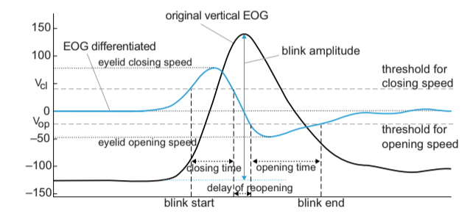

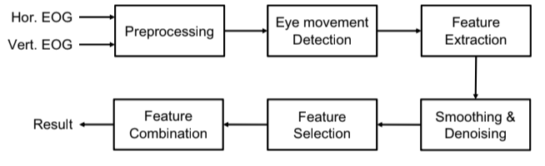

1. Pre-processing:   
   Use a 30 Hz low pass filter.
   1. Baseline drift removal  
      Remove the baseline drift by performing the wavelet transform.
   2. Independent Component Analysis  
      This method of preprocessing is optional as the noise present in the EOG is not significant.
2. Eye Movement Detection  
   Capture the Horizontal and vertical EOG.
   1. SEM (Slow Eye Movements)   
      SEMs are detected using the horizontal EOG. The SEM value is computed using **Discrete Wavelet Decomposition** which involves, Wavelet decomposition, Energy Computation, and Discriminant function. (**TODO: Nhat, check Wavelet Decomposition**)
      1. Discrete Wavelet Decomposition:  
         The signal is processed by a 10-level DWT by Daubechies order 4 (db4) wavelet. This divides the signal into 10 components.
   2. Saccade Detection **(TODO: Distinction between SEM and saccade)**  
      Saccades are detected with the of the horizontal EOG.
      1. Process the signal through a filter of 1Hz to 8Hz.
      2. Compute the velocity of the eye movement.
      3. Find all points which are greater than the threshold.
   3. Blink Detection **(TODO: Find the way to compute the thresholds)**Thie dual threshold method is performed on the vertical EOG.
      1. Process the vertical EOG signal by passing through a 10Hz low pass filter.
      2. Calculate the speed of the eyelid.
      3. Apply the dual thresholds Vcl and Vop and extract 4 successive points.
      4. Combine the blink candidates together if they are close to each other.
      5. Verify the duration and amplitude of blink candidates
3. Feature Extraction
   1. Three features are extracted from SEM: proportion, mean and variance of amplitude.
   2. Four features are extracted from the Saccades: proportion, peak velocity, mean and variance of amplitude.
   3. Eleven features for Blink: duration, closing/opening time, delay of opening, delay time ratio. Interval, mean amplitude, closing/opening peak velocity, and opening and closing mean velocity.
   4. Two features are extracted for energy: The power spectral densities PSDs of low frequency (0 to 1 Hz) on horizontal and vertical EOG.
4. Smoothing and Denoising:
   1. LDS (Linear Dynamical System), a semi-supervised Dynamic model is used for smoothing.
5. Feature Combination  
   The combined features have shown better results than single features. Combines using:
   1. Linear Summation:  
      All the features are added together after normalization.
   2. PCA:  
      The projection resulted from the PCA is used.
   3. Manifold learning:  
      Non-linear unsupervised learning method for dimension reduction. In the paper, Isomap is used which makes use of the geodesic distance.